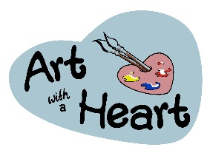 | Call for Artists: Altrincham Open 2016  7th July-14th August 2016

Exhibition Entry Form

Artist Information
Full Name:
 | First | Last
Address:
 | Street Address
 | City |  | ZIP Code
Contact Email: |  | Contact Number:

Website:

Artwork Information
In addition to the details below, please attach images of the work. These can be attached physically or sent via email to bex@artwithaheart.org.uk. All artist can enter up to three piece of work at £5 per piece. Payment can be made in cash, cheque (made payable to ‘Art with a Heart’) or via the donate button on our website. If paying online please forward your receipt.

WORK ONE:
Title: |  | Medium:

Dimensions: |  | Price:

WORK TWO:  Title: |  | Medium:

Dimensions: |  | Price:
WORK THREE:  Title: |  | Medium:

Dimensions: |  | Price:

Deadline for entries 12th June 2016. You will be informed by the 16th June whether your entry/entries have been successful. Drop off dates are 18th June-3rd July 2016.

Please read our terms and conditions before signing this form, as this indicates your agreement to the terms and conditions
SIGNATURE: |  | DATE:

ADMIN USE ONLY:
☐ | ARTWORK SELECTED | ☐ | ARTWORK COLLECTED | ☐ | PAYMENT RECEIVED. ( )

