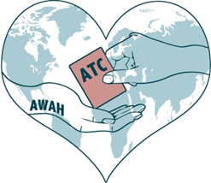**Art with a Heart School Trading Cards Project**

**Project Guidance Notes**

OCTOBER 2015-DECEMBER 2015

**Project Title - Transformations**

Suggested participant groups: GCSE/A Level

Deadline for entry: 20th December 2015

Along with this guidance sheet you will have received enough blank cards for your students to complete their entries.

Students will need to produce 2 trading cards on the current exhibition theme; one to be displayed in our gallery and online, and the other to be traded with another school. The exhibited card will be returned to the student at the end of the exhibition.

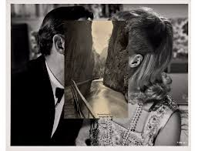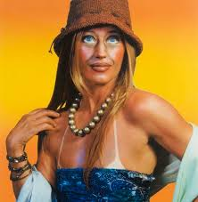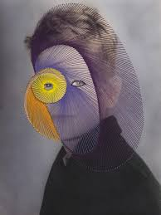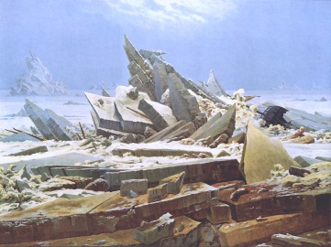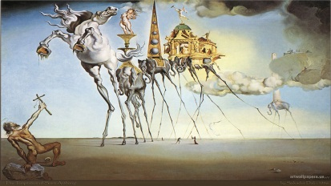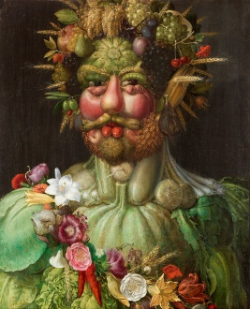Possible Starting Points

John Stezaker

Cindy Sherman

Maurizio Anzeri

Caspar David Friedrich

Salvador Dali

Giuseppe Arcimboldo

**Photography**

Photography and photomontage can be used to manipulate and distort the perception of an

image.

Anzeri uses graphic stitches

which seem to feed off of the

contours of the face, Stezaker

seamlessly combines images

and Sherman uses her own face

as a canvas for a multitude of

characters.

**Fine Art**

Artists have for many years used painting to depict humans and the world around them in surprising ways.

Arcimboldo championed the use of painted collaged objects, fruit and vegetables, transforming them in

to features. Friedrich captured the

transformation of landscape in

dramatic, angular images, and Dali

literally stretched, distorted and

blended together reality to form

grotesque and emotional people

and places.

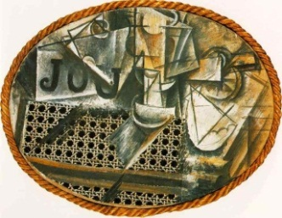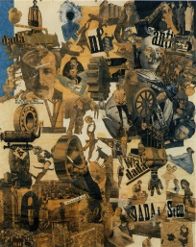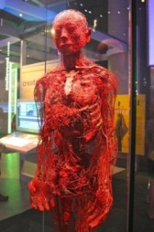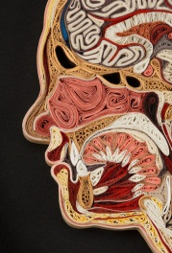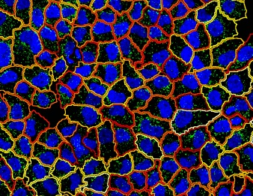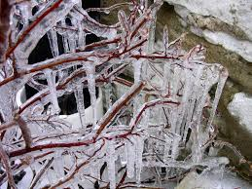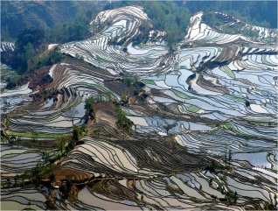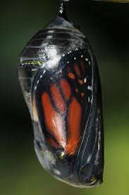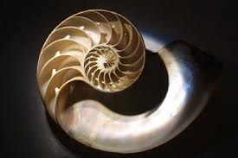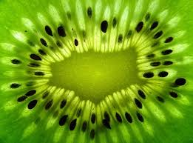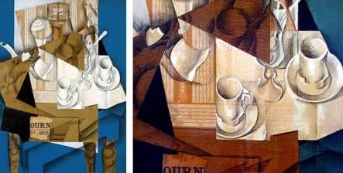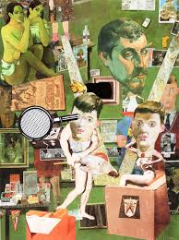

**How to enter your class designs:**

* Remember, each student must complete 2 designs; one for the gallery and one to share with another school.
* Number and name each entry, and include the entry form provided in this pack.
* Only 2D materials to be used to ensure the finished cards can be displayed in wallets.
* Be as individual and creative as you can.
* Feel free to use an alternative backing paper, just be sure the dimensions match the card provided.
* Good luck and we can’t wait to see what you come up with!

Lisa Nilsson

Hannah Hoch

**Science and Industry**

Whether it’s transforming energy in to motion

and heat, the transformation of cells, the

regeneration of the human body or simply

chemical reactions, science and industry

presents us with endless inspiration. Artists

such as Hoch have used industrial imagery in

collage effect. Artist Lisa Nilsson sees beauty in

the human makeup and

uses quilling to illustrate

this fascination.

Pablo Picasso

Juan Gris

Peter Blake

**The Natural World**

Nature presents us with transformations every second. It might be the growth of a flower or changes in

season. The transformation from

caterpillar to butterfly or hatching of a

chick show the adaptability and robust

nature of natural forms. You may wish

to explore how nature in itself can be

explored as pieces of art,

transforming how we view the

world and inspiring the creative

works of artists.

**Mixed Media**

Mixed media has been used to transform the texture, tone and form of piece of 2D

work to great success by many

artists. Picasso and Gris

blended text and material

with their cubist paintings.

Peter Blake illustrates his time

capsule pieces using cultural

references in collage.