    - Alena Katikova
    - John Dempsey
  For this sculpture John has transformed a discarded chair with an unwanted doll to produce an artwork which offers a challenge to perceived political wisdom.
  This sculpture design was inspired by an article written in the Seattle Times, USA, on July 24 2010 by their regular staff columnist Danny Westneat. The theme of the article was the generally accepted image of the cowboy farmers of Washington as the backbone of the USA, rugged individuals who rely on no one but themselves was in fact pure baloney. One of their number, Clint Didier, ex US Super Bowl footballer and now a farmer of sagebrush is running for Senate on the platform of drastically reducing taxpayer funds providing welfare support for the elderly, and for medical aid- “…we don’t need the government to come in and try to prop things up-these are typical quotes made by Clint Didier. In fact Washington State’s farmers could not survive without the huge taxpayer subsidies they receive which provides them with funds to pay for their electricity, so providing cheap water and they also receive generous taxpayer subsidies for their crop prices-a total of $4 billion since 1995, Didier himself received $273,000 of that taxpayers help.
  So it seems that if the lone cowboys are saying recipients of public welfare are leeching off the State-then they must also be leeches-that is why my cowboys are red. Bankers, lone cowboys…..
  The Great American Myth
  Before Image
  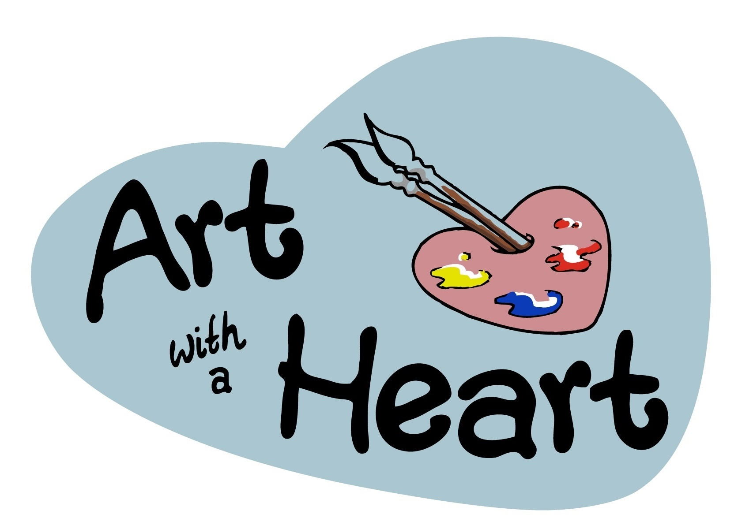
  Art with a Heart
  82-84 George Street
  Altrincham
  WA14 1RF
  www.artwithaheart.org.uk

