    - Alena Katikova
    - Helen Davies
  Helen Davies is a contemporary glass artist who studied at the North Wales School of Art and Design. She set up F I R E D Contemporary Glass producing handmade timeless pieces in her studio in Lymm. Influenced by nature and the elements, her artwork adds ambiance to its given surrounding.
  Helen’s work is a transformation of the materials and their original purpose. The glass is purely window glass, transformed with injections of colours in the form of powders and frit (small pieces of glass) in a wide variation of colours. The wood in which the glass is mounted is, again, a transformation of offcuts from the building trades’ waste wood. The two combined compliment the tones found within each piece of bespoke glass artwork.
  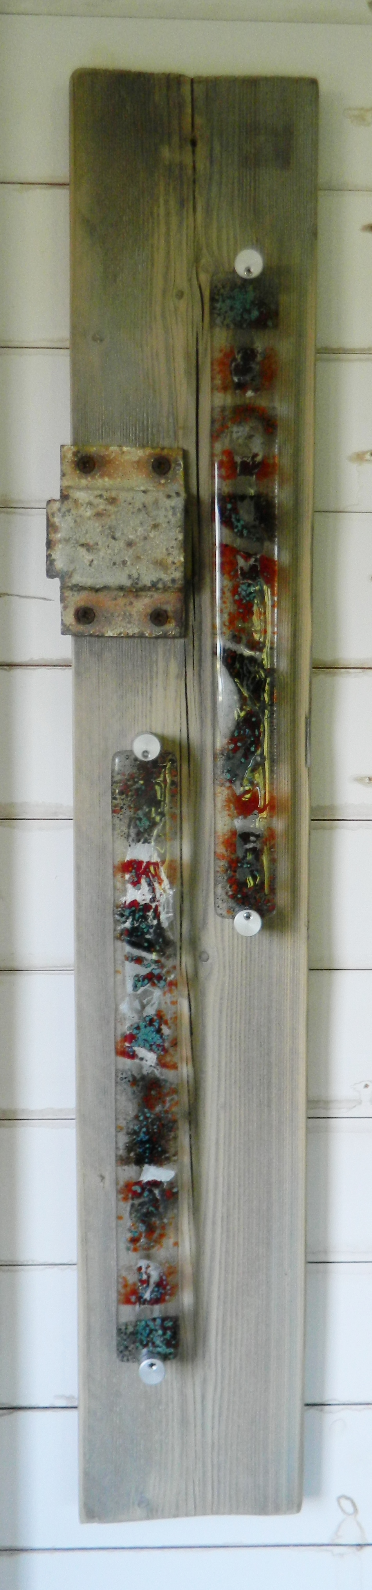
  Untitled
  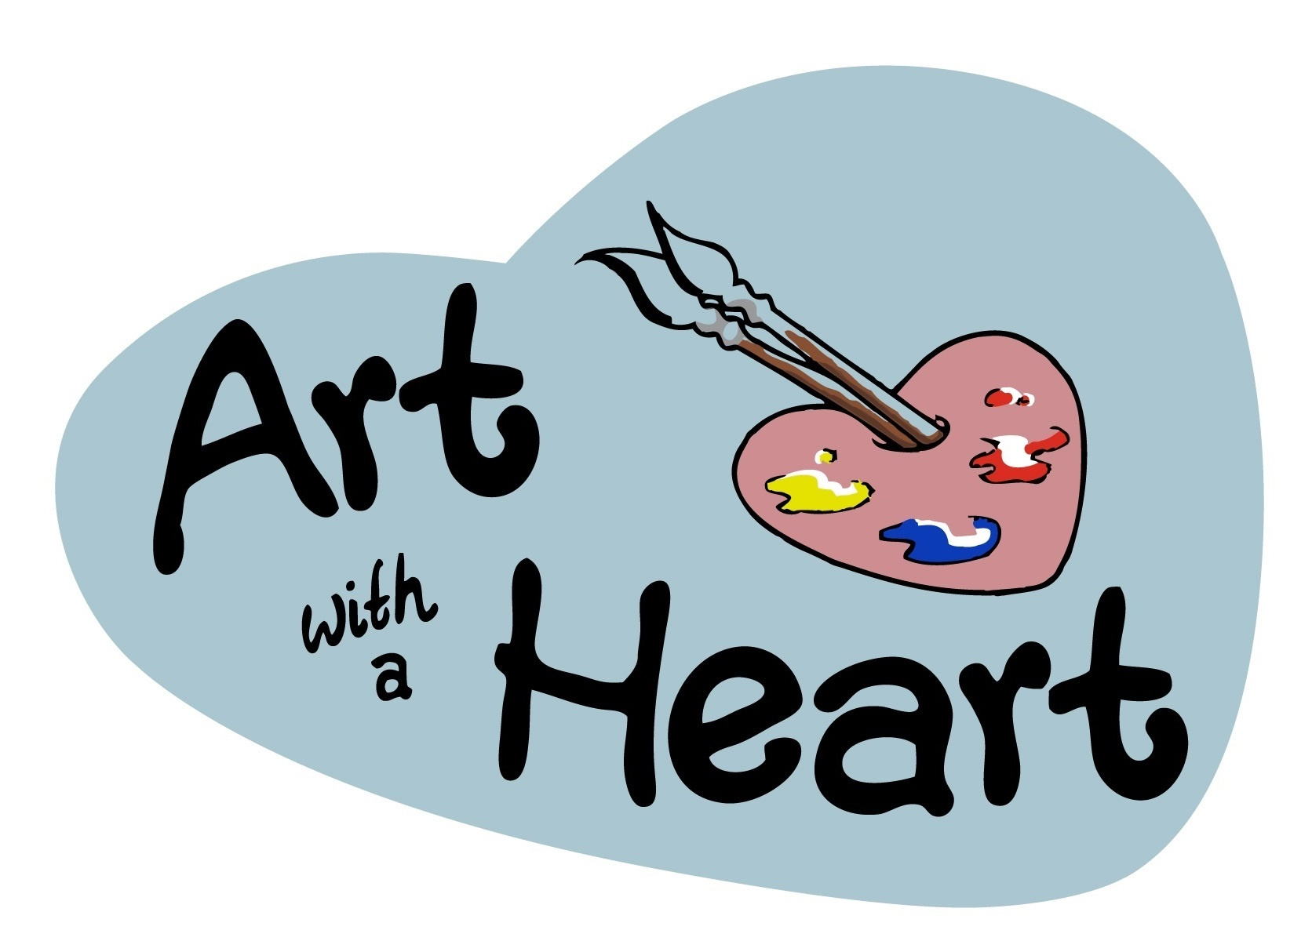
  Art with a Heart
  82-84 George Street
  Altrincham
  WA14 1RF
  www.artwithaheart.org.uk

