    - Alena Katikova
    - Alena Katikova
  Alena Katikova’s submission is taken from the series of collages which are part of project called "Individualization of Certain Forms"; which is her artist’s master thesis, as she is currently on her postgraduate studies.
  It can be interpreted as a portrait. This work was not originally created as portrait of a real person, but on the contrary, were modeled on other head-shaped object - a cactus, in this case. In this way, looking at inanimate object (in the full sense of the word ("I think, therefore I am") the object becomes alive, thanks to this marvelous ability of art to transform anything, and therefore the qualities of certain characteristics are transferred to them. Cactus is not a cactus, it is a portrait depicting one his own, durable figure in its creation.
  Alondra is a fun, expressive and driven person. She is dynamic and temperamental. She is the one that always brings any ordinary experience to another level. Strong color contrast imply strong, but not always desirable features.
  Mario is calm, prudent, ambitious and well organized. He is also kind of choleric, as is the person who made him.
  The artworks are created using various different materials that are collaged together. She combined different textures in hope for gaining richer versatility of her work. Different areas reflect different characteristic and their unique combination.
  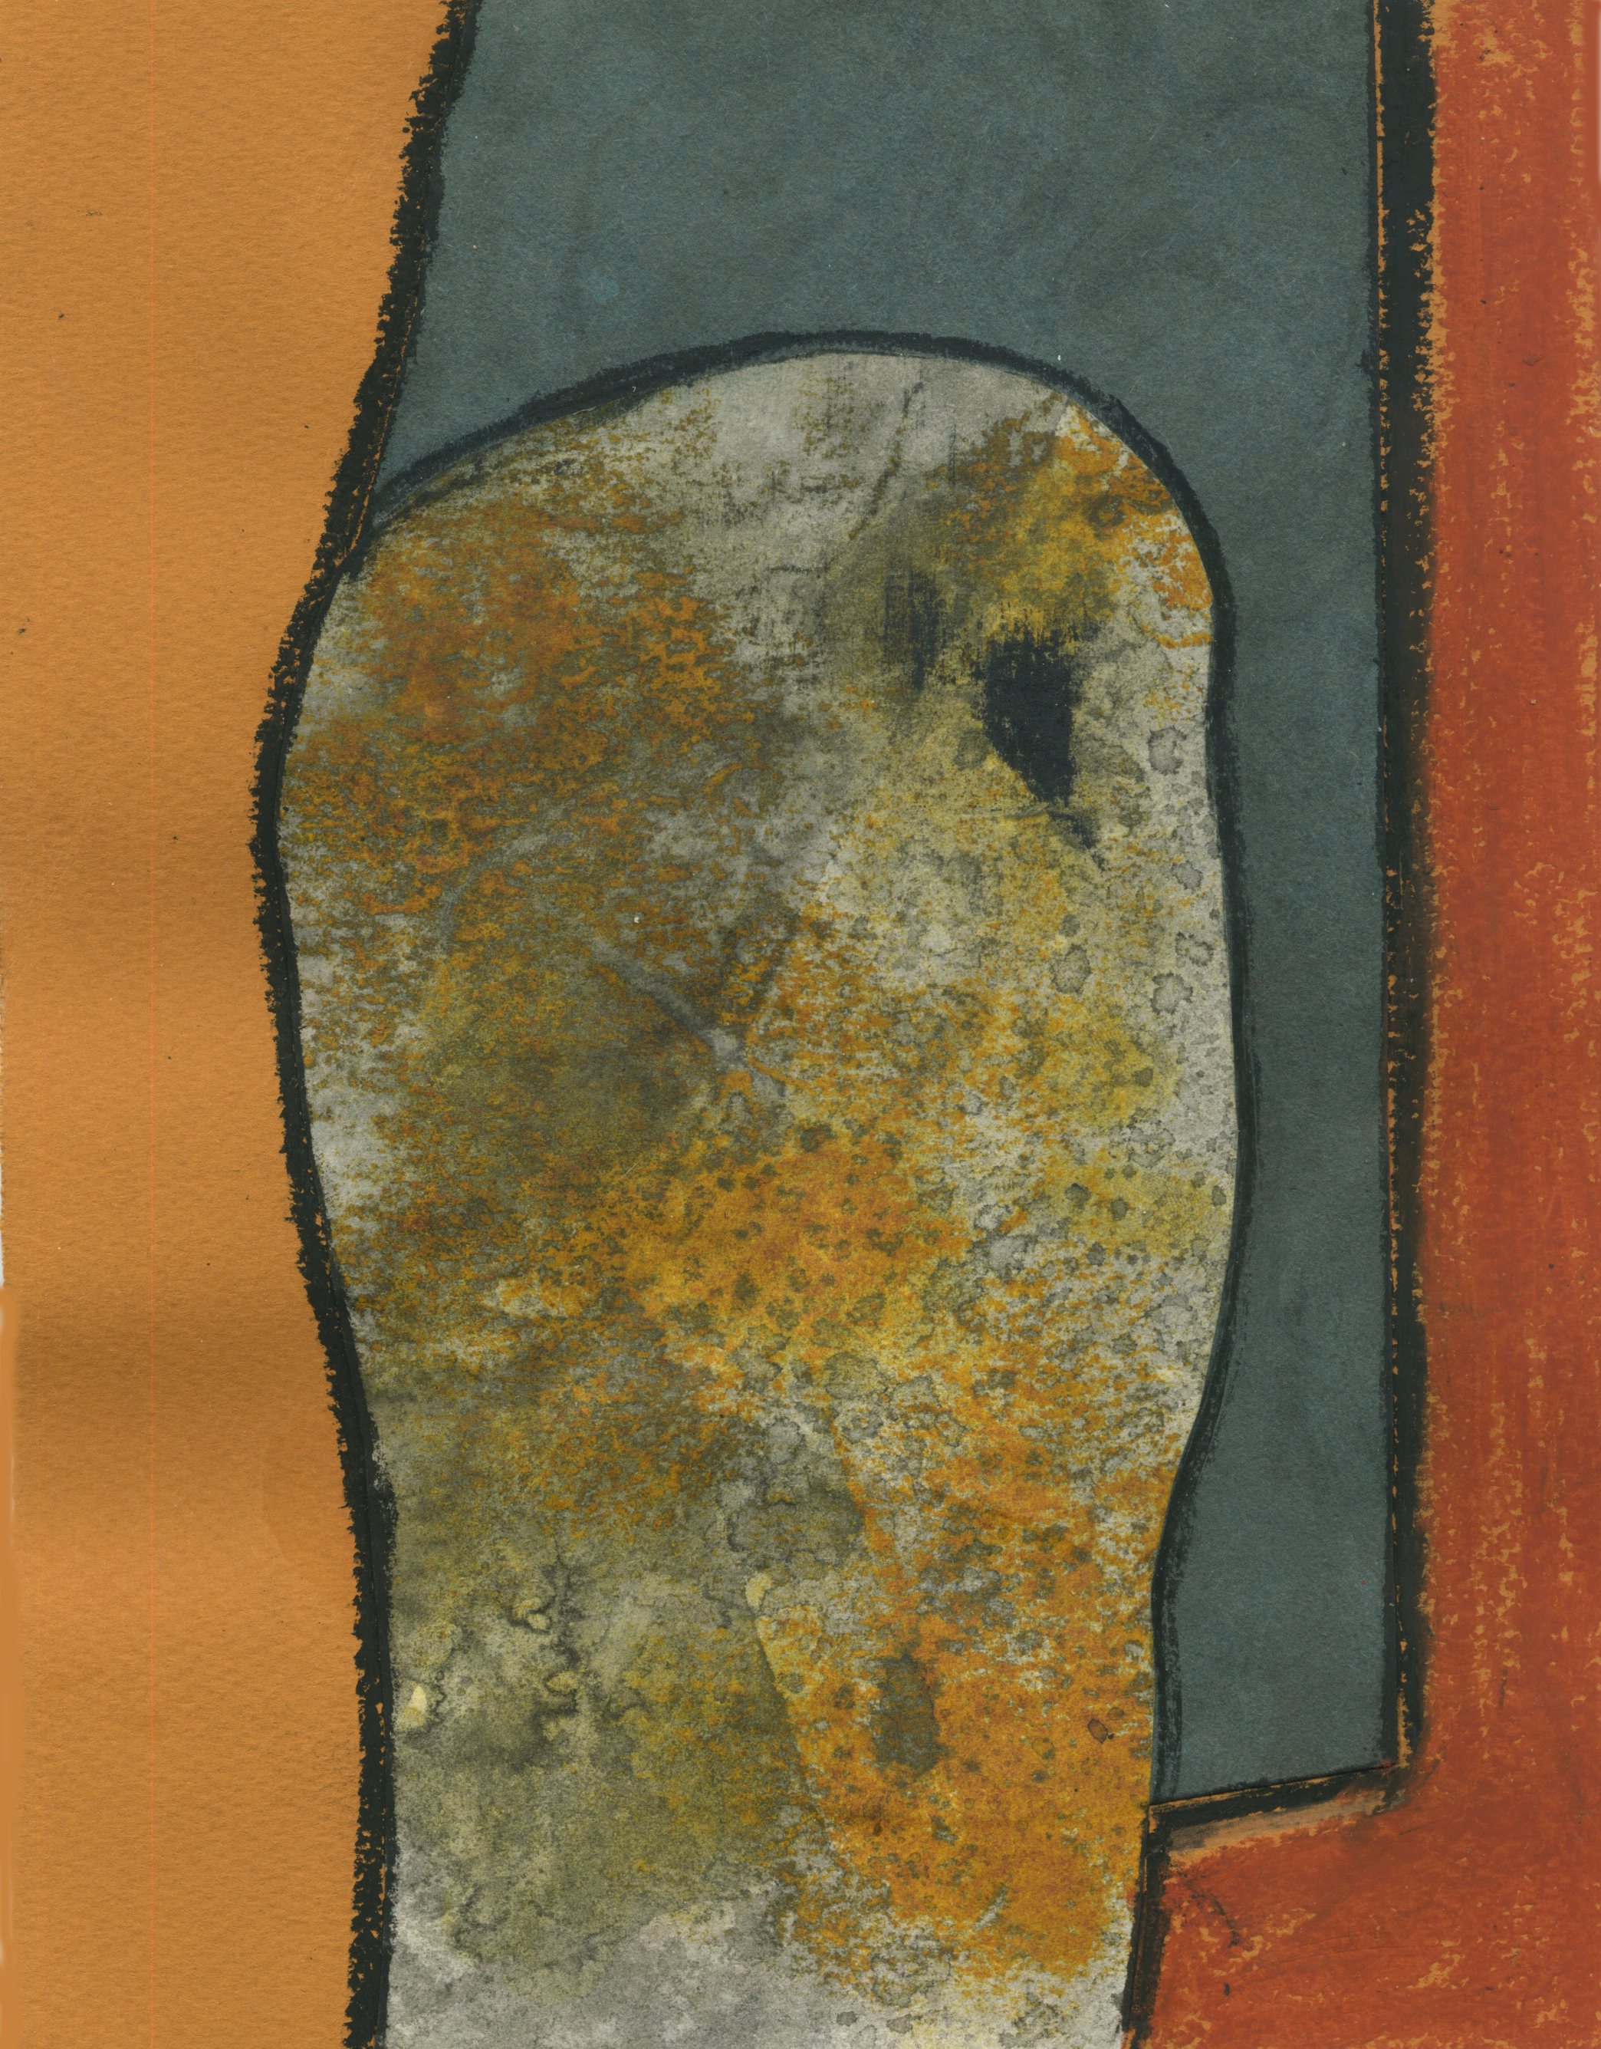Alondra
  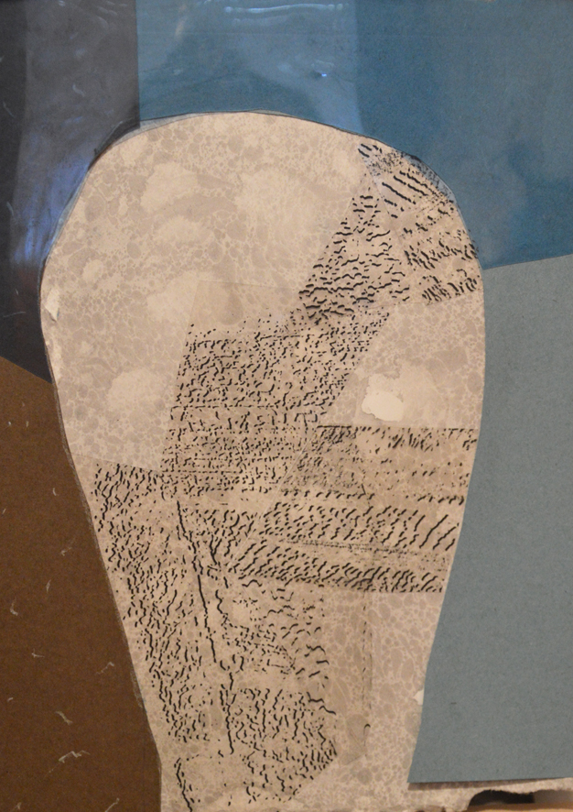
  Mario
  Alona
  Alona
  [One More Point Here!]
  [Add More Great Info Here!]
  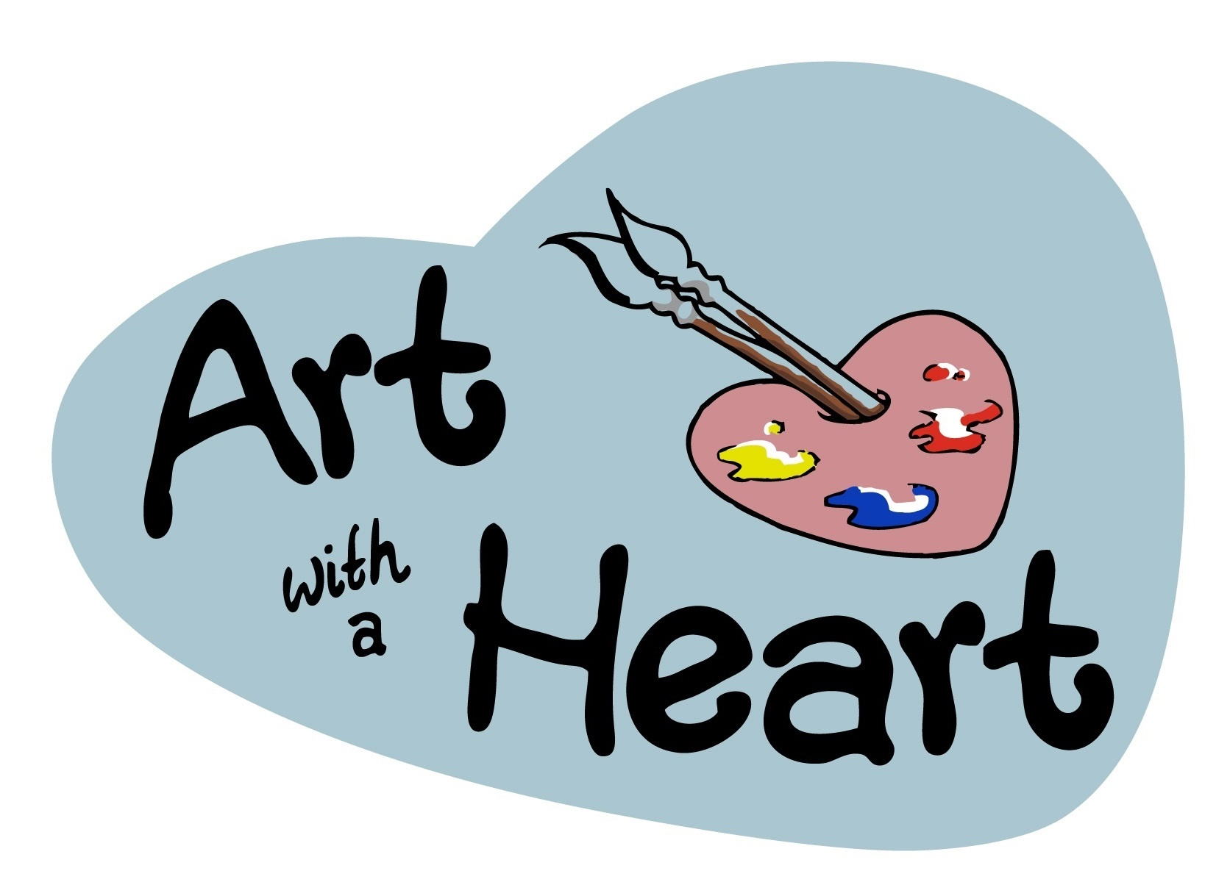
  Art with a Heart
  82-84 George Street
  Altrincham
  WA14 1RF
  www.artwithaheart.org.uk

